MANGOCHI CATHOLIC DIOCESE MOCK EXAMINATIONS
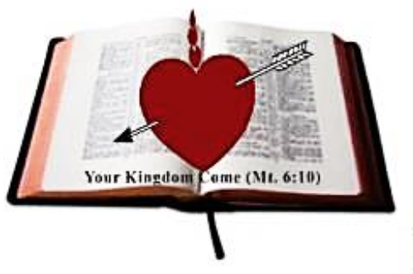
2025 MALAWI SCHOOL CERTIFICATE OF EDUCATION
BIOLOGY
SUBJECT NUMBER: M 022/II
Tuesday, 27 May 2025 Time Allowed: $1{\frac{1}{2}}$hrs
10:00 am onwards
PAPER II
(40 marks)

Question number | Tick if answered | Do not write in these columns
1
2
3
4
Total
Instructions

- This paper contains 5 printed pages. Please check.
- Write your Examination Number at the top of this page and every sheet.
- This paper contains two sections A and B. section A has two descriptive questions and section B has two questions on experiment.
- Answer all four questions in the spaces provided in the question paper. The maximum number of marks for each answer is indicated against each question.
- All diagrams must be done in pencil.
- In the table on this page tick against the question you have answered.
- At the end of the examination, hand in your question paper to the invigilator when time is called to stop writing.

© 2025 MH DIOCESE Turn Over

SECTION A (20 marks)
- Describe an experiment that could be carried out to show the effect of an exercise on the rate of breathing in an essay form. Your answer should include the following: procedure, expected results and conclusion.
______________________________________________________________________________________________________________________________________________________________________________________________________________________________________________________________________________________________________________________________________________________________________________________________________________________________________________________________________________________________________________________________________________________________________________________________________________________________________________________________________________________________________________________________________________________________________________________________________________________________________________________________________________________________________________________________________________________________________________________________________________________________________________________________________________________________________________________________________________________________________________________________________________________________________________________________________________________________________________________________________________________________________________________________________________________________________________________________________________________________________________________________________________________________________________________________________________________________________________________________________________________________________________________________________________________________________________________________________________________________________________________________________________________________________________________________________________________________________________________________________________________________________________________________________________________________________________________________________________________________________________________________________________________________________________________________________________________________________________________________________________________________________________________________________________________________________________________________________________________________________________________________________________________________________________________________________________ (10 marks)
Continued/…
- Describe an experiment that could be carried out to show the effect of light distribution on a growing shoot in an essay form. Your answer should include the following: procedure, expected results and conclusion.
____________________________________________________________________________________________________________________________________________________________________________________________________________________________________________________________________________________________________________________________________________________________________________________________________________________________________________________________________________________________________________________________________________________________________________________________________________________________________________________________________________________________________________________________________________________________________________________________________________________________________________________________________________________________________________________________________________________________________________________________________________________________________________________________________________________________________________________________________________________________________________________________________________________________________________________________________________________________________________________________________________________________________________________________________________________________________________________________________________________________________________________________________________________________________________________________________________________________________________________________________________________________________________________________________________________________________________________________________________________________________________________________________________________________________________________________________________________________________________________________________________________________________________________________________________________________________________________________________________________________________________________________________________________________________________________________________________________________________________________________________________________________________________________________________________________________________________________________________________________________________________________________________________________________________________________________________________________________________________ (10 marks)

Continued/…
SECTION B (20 marks)
- You are provided with the following: specimens Q and R, knife, hand lens, ruler and pencil
- State the scientific name for specimen R
_________________________________________________________________

(2 marks)
- Use a knife to make a transverse section of specimen R.
Draw the transverse section and label any two parts.

(3 marks)
- Explain one observable adaptation to survival in a hot desert climate of the specimen Q.
________________________________________________________________________________________________________________________ (2 marks)
- State any two ways in which specimen R may help to conserve the ecosystem.
_________________________________________________________________________________________________________________________ (2 marks)
- Name the planting material for specimen Q
________________________________________________________ (1 mark)
- You are provided with the following: specimens X and Y, ruler, pencil and a knife.
- Use the knife to make a cross section of specimens X and Y. Give any two structural similarities between them.
_________________________________________________________________________________________________________________________________________________________________________________________ (2 marks)

Continued/…
- Measure the diameter of specimen Y in millimeters.
________________________________________________________ (1 mark)
- Draw a cross section of specimen X and label any two parts.

(3 marks)
- Calculate magnification of specimen X from your drawing in 4 c

(3 marks)

- State any one observable feature to show that both X and Y rose from a common ancestor.
_________________________________________________________ (1 mark)

END OF QUESTION PAPER
NB: This paper contains 5 printed pages

